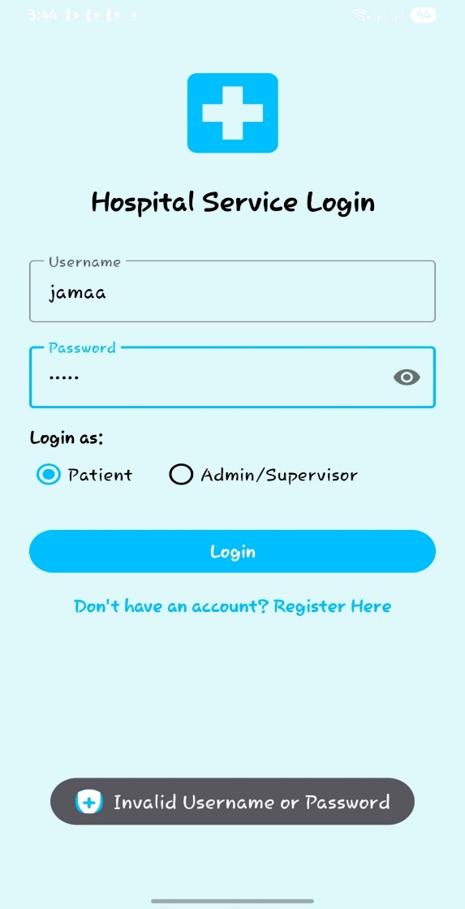
1.User has not registered to the app that’s why the error message popped

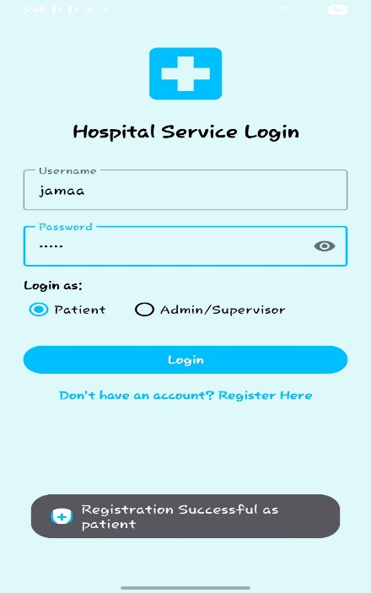
2.User has not filled the required fields hence cannot submit service request
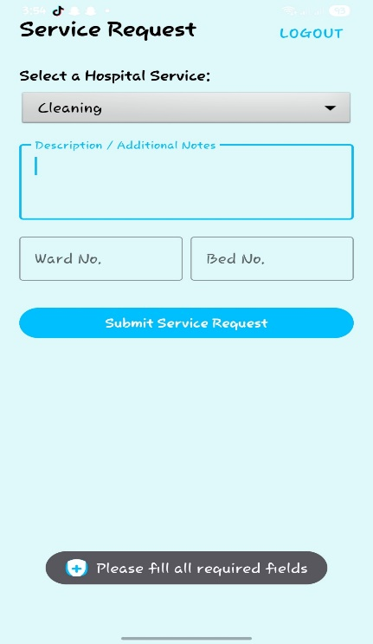

4.After user has filled the fields can now submit the request successfully
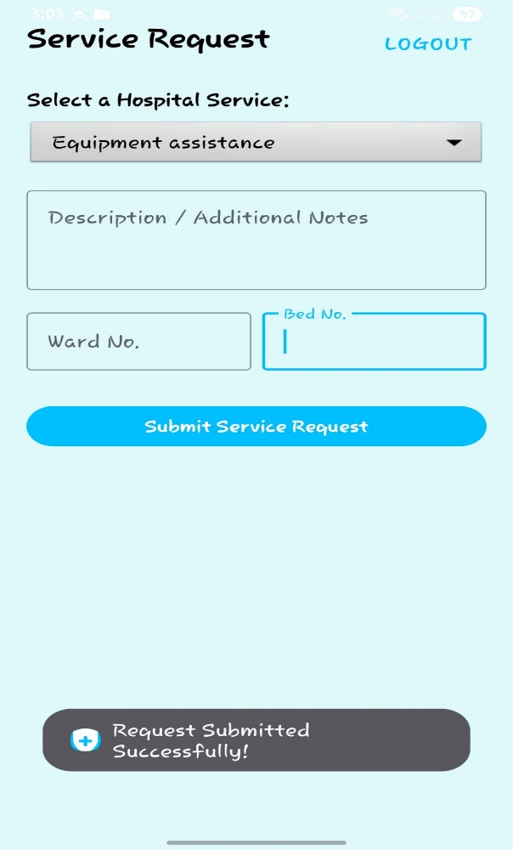
1.Error type: Environment
What it looked like: "JDK not defined"
Solution: Assigned JDK 17 so the computer could read the code.
2.Error type :Syntax
"XML target not allowed"
Solution: Removed a double <?xml?> tag in the layout file.
3.Error type: Navigational
"ActivityNotFound"
Solution: Added new pages to the Manifest file so the app found them.
4.Error type: Deprecation
"Method is deprecated"
Solution: Replaced an old command with a newer version to prevent crashes.
5.Error type :Readability
"Low contrast/Pink text"
Solution: Edited Theme files to force Black text against the blue background.
6.Error type: Logic
"NullPointerException"
Solution: Fixed the code so it "finds" the Logout button before using it

